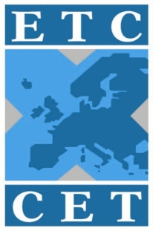 |  |  | 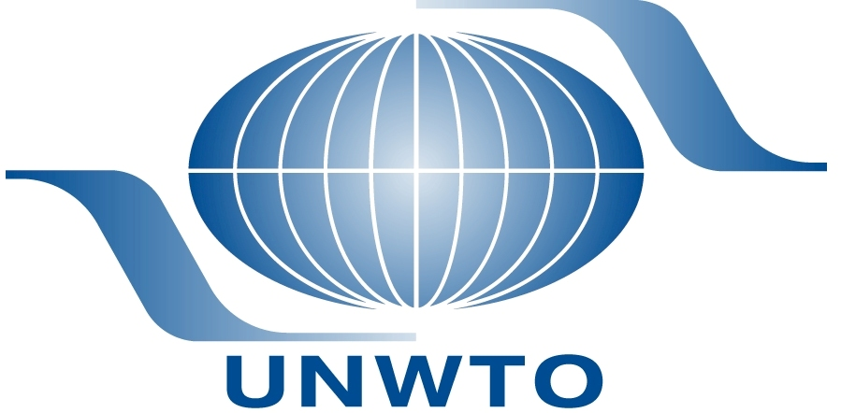

ETC - UNWTO Joint International Seminar on
Tourism Product Development

Organized by the European Travel Commission,
the World Tourism Organization
& Fáilte Ireland

REGISTRATION FORM

Venue: Bewley’s Hotel Ballsbridge
Merrion Road, Ballsbridge,
Dublin 4 - IRELAND
www.bewleyshotels.com/ballsbridge

12-13 May 2011

Please return this form by 26th April 2011 (by e-mail) to the contact persons at Fáilte Ireland & ETC listed at the end of this form.

Delegate Registration Details
Country:
Name:
Job title:
Company:
Office address:
Telephone:
E-mail:

Attendance at Meetings
ETC-UNWTO Seminar on Tourism Product Development
Thursday 12th May 2011

ETC-UNWTO Seminar on Tourism Product Development
Friday 13th May 2011

Welcome Dinner & Reception
Dinner for seminar delegates at Thomas Prior Hall
Thursday 12th May (20.00)

Accompanying person´s details

Name of accompanying person:

Welcome Dinner & Reception for Accompanying person

Should you wish to purchase a ticket for an accompanying person to the Welcome Dinner & Reception, you can do so during Registration in Bewleys Hotel.
The Ticket Price is € 53 per accompanying person.

Accommodation

Accommodation is available at the Seminar Hotel - Bewleys Hotel, Ballsbridge www.bewleyshotels.com/ballsbridge. Tel: +353 1 6473300
Booking
A special rate has been arranged with Bewley’s:
Single occupancy: € 79.00 (Breakfast & tax included)
Double Occupancy € 89.00 (Breakfast & tax included).
Please make your reservation directly with the hotel quoting the promotional code “UNWTO”

Payment
This should be made directly to the hotel during checkout.

Please note: The hotel has agreed to reserve a certain number of rooms for delegates until April 28th 2011. If you decide to book after this time and the hotel is full there are many other hotels in the area. Please see the list under General Information at the end of this document.

Please return this form by 26th April 2011 (by e-mail or fax)
to the following persons:

Send to:  Aideen Kelly  Fáilte Ireland  Amiens Street  Dublin 1 - IRELAND  Tel: +353 1 - 884 7205  e-mail: aideen.kelly@failteireland.ie | with a copy to:  Aline Biber  European Travel Commission  19A Avenue Marnix (Boîte 25)  1000 Brussels - BELGIUM  Tel: 00 32 2 - 548 9000  Fax: 00 32 2 - 514 18 43  e-mail: aline.biber@visiteurope.com

General Information

Seminar Venue
The venue for the ETC – UNWTO Joint International Seminar on Tourism Product Development is the Thomas Prior Hall in Bewleys Hotel, Ballsbridge.

Hotel Accommodation
Bewleys Hotel is the Seminar hotel. It is situated in the fashionable, exclusive Ballsbridge area of Dublin in the heart of the Embassy belt. It is just a 10-minute drive or half an hour walk from the city centre. The city centre is also easily accessible by the DART (local rail network) and the nearest station is five minutes’ walk away. Its location makes it a good base for exploring Dublin’s many tourist attractions such as Trinity College, museums and National Art Gallery. Delegate accommodation has been reserved at a special rate. Should you wish to book a room, please contact the hotel directly using the following promotional code “UNWTO”
Hotel details:
Bewleys Hotel
Merrion Road,
Ballsbridge,
Dublin 4
Tel: +353 1 6473300 .
Website: http://www.bewleyshotels.com/ballsbridge/

Should you choose to stay in an alternative hotel, hotels within the vicinity of the Seminar venue include:
- Four Seasons Hotel http://www.fourseasons.com/dublin
- Sandymount Hotel http://www.sandymounthotel.ie
- The Schoolhouse Hotel, http://www.schoolhousehotel.com,
- Herbert Park, http://www.herbertparkhotel.ie
- Burlington Hotel, http://www.burlingtonhotel.ie

Welcome Dinner & Reception
There will be a Welcome Reception and Dinner in the Thomas Prior Hall of Bewleys Hotel on Thursday 12 May 2011 at 20.00 hours. This is an opportunity to meet and network with delegates attending the Seminar.

Reserving Your Place at the Seminar
To reserve your place at the Seminar please complete the attached form and return to the contact persons at Fáilte Ireland and ETC listed at the end of this form.

Entry to Ireland
In order to enter Ireland, all visitors must possess a valid passport. Visas may be required for some non-EU citizens. Please check with your local Irish Embassy/Consulate or on the Irish Department of Foreign Affairs website http://www.foreignaffairs.gov.ie/

Travelling from Dublin Airport
Dublin Airport is serviced by a number of private and public bus companies, which can be found just outside the terminal buildings. Bewleys Hotel is serviced directly by one private bus company, Aircoach http://www.aircoach.ie , which has departures every 15 minutes from Dublin Airport. Transfer time approx 30 – 40 minutes. Cost €14.00 return, €8.00 single.

The taxi fare to the Bewleys Hotel is approximately €35.00.

Currency
The Irish currency is the Euro.

Language
English is the principal language of commerce throughout Ireland.

Electricity
Electricity is 220V in Ireland

Tourist Information
For information on ‘Things to Do’, Restaurants, Bars and Insider Guides go to Dublin Tourisms Website http://www.visitdublin.com or alternatively go to Fáilte Ireland’s consumer website which is http://www.discoverireland.com.

In addition there are a number of Tourist Information Offices around Dublin including one at Arrivals in Dublin Airport.

